# Assignment 10 -Portfolio

# 21LEM301T– Indian Art Forms

*Submitted by*

**Hayden Varughese Cheriyan – [RA2311030010238]**



**DEPARTMENT OF NETWORKING AND COMMUNICATIONS**

**FACULTY OF ENGINEERING AND TECHNOLOGY SRM INSTITUTE OF SCIENCE AND TECHNOLOGY**

**KATTANKULATHUR – 603 203 NOVEMBER**

**2025**

**SRM INSTITUTE OF SCIENCE AND TECHNOLOGY KATTANKULATHUR – 603 203**

**ASSIGNMENT-1**

Interactive Timeline with Artifacts

Description: Create an interactive digital timeline that includes virtual

replicas of key artifactsfrom different periods of Indian art. Each artifact

can be clickable, providing detailed information and historical context.

Link: <https://www.tiki-toki.com/timeline/entry/2186782/Vijayanagara-Empire-Timeline/>

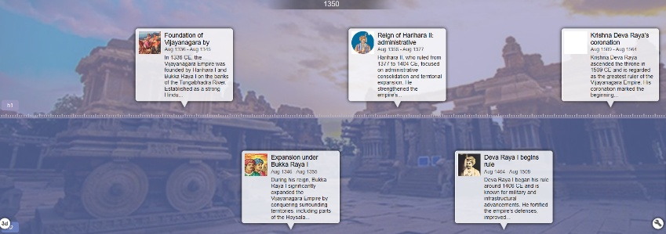

**ASSIGNMENT-2**

Title: Interactive Art Map (10 Marks) – CO1

• Description: Create an interactive digital map highlighting key

locationssignificant to Indian art history. Each location can include

images, descriptions, and historical context about local art movements,

artists, and artworks.

Story Map LINK: <https://googieman.github.io/>

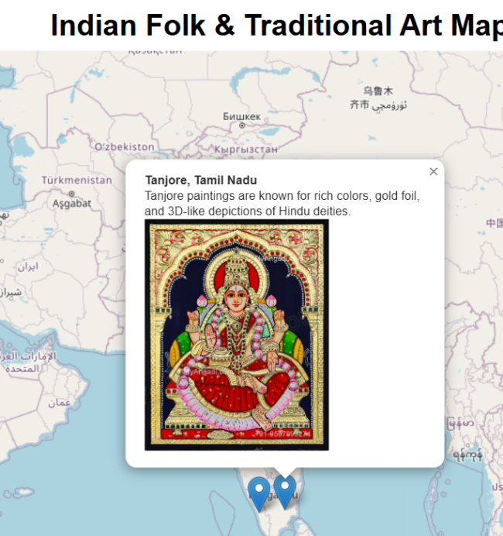

**Assignment 4**

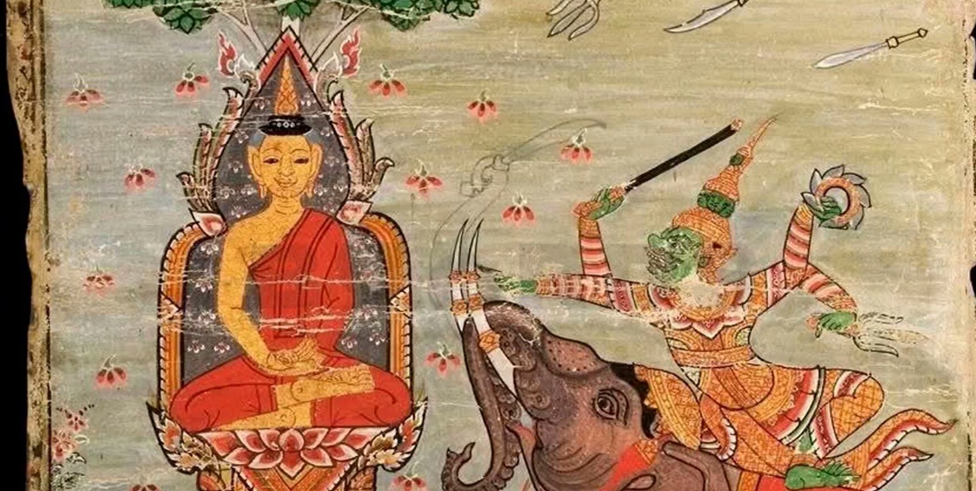

Link :- <https://github.com/HaydenRA238/Indian-Art-Forms.git>

**Assignment 5:**

**Introduction**  
Mahabalipuram (Mamallapuram), on the Coromandel coast of Tamil Nadu, is a UNESCO World Heritage Site renowned for its rock-cut monuments, monolithic temples, and narrative bas-reliefs created primarily during the Pallava dynasty (7th–8th century CE). Under the patronage of Narasimhavarman I (Mamalla) and later Rajasimha (Narasimhavarman II), the site became a laboratory for artistic and architectural innovation. The monuments reveal a pivotal transition: from cave-cut sanctuaries (mandapas) into free-standing structural temples, anchoring the emergence of the Dravidian style. Their purposes were manifold—acts of royal devotion and political legitimation, a didactic visual scripture for the public, and bold experimentation in form, iconography, and spatial narrative.

**Overview of the Rock-Cut Sculptures**  
Mahabalipuram’s monuments can be grouped into three broad types:

* Cave Temples (Mandapas): Excavated sanctuaries with sculpted pillars and narrative reliefs on the interior walls. Exemplars include the Varaha Mandapa, Mahishasuramardini Cave, and Krishna Mandapa. They present mythic episodes in high and low relief, integrated with the architectural rhythm of columns and sanctum space.
* Monolithic Rathas (Pancha Rathas): Carved from single granite outcrops, these “chariot-temples” are complete architectural forms sculpted out of living rock. They are not functional temples but prototypes and exercises in formal vocabulary—vimana tiers, kapota cornices, aedicules, and lion or elephant balustrades—demonstrating diverse plans and superstructures.
* Open-Air Bas-Reliefs: Monumental narrative sculptures carved on exposed rock faces, the most spectacular being the Descent of the Ganges/Arjuna’s Penance. These compositions employ the natural cleft and contour of the rock, creating an immersive theatricality.

Materials and Techniques: The medium is local granite—hard, coarse, and unforgiving—worked with hammer and chisel. Artisans mastered shallow and deep relief to model bodies, drapery, and motion; they leveraged the rock’s natural fissures and planes, and minimized applied materials, relying on the stone’s mass and luminosity.

**Themes and Iconography**  
A. Religious Themes  
Mahabalipuram articulates a robust Hindu pantheon, with Shaivism and Vaishnavism in energetic dialogue.

* Shaivism Dominance: Shiva appears as Gangadhara (receiver of the Ganga’s descent), as the boon-giver to the ascetic Arjuna, and in familial Somaskanda panels (Shiva-Parvati with Skanda). Dvarapalas flank sanctums with leonine vigor; linga cult imagery anchors royal piety and cosmic authority.
* Vaishnavism Representations: Vishnu’s avatars, especially Varaha (boar) and Vamana/Trivikrama, dramatize the divine restoration of order. Gajalakshmi panels express prosperity and auspiciousness, linking temple, kingship, and wellbeing.
* Mythological Narratives: Arjuna’s severe tapas to obtain the Pashupatastra from Shiva and Bhagiratha’s penance for the Ganga’s descent are paired narratives of ascetic devotion, divine grace, and the world-ordering descent of sacred waters.

B. Cultural Themes  
The monuments encode royal authority, ascetic virtue, and communal life.

* Royal and Ascetic Ideals: Kingship is cast as dharmic stewardship under divine sanction; asceticism (tapas) is exalted as a transformative path, symbolically aligning the ruler with sage-like restraint and duty.
* Lived Culture and Nature: Panels teem with domestic and pastoral scenes—cowherds, women with water pots, musicians, playful children—and vivid animal life: elephants, lions, deer, makaras, and nagas. The divine-human-natural continuum asserts a harmonious cosmic ecology.
* Tamil-Dravidian Ethos: The sculptural language integrates early Tamil cultural sensibilities—valor, devotion (bhakti), fertility symbols, and kinship—with pan-Indian mythic frameworks.

C. Artistic Themes

* Sculptural-Natural Harmony: Compositions adapt to and dramatize the rock’s clefts, slopes, and planes, turning geology into iconography.
* Relief Mastery: Alternation of low and high relief creates spatial depth, kinetic rhythms, and expressive silhouettes in hard granite.
* Realism and Dynamism: Anatomical vitality (notably in elephants), balanced stances, and flowing lines communicate motion and psychological nuance.
* Prototyping the Dravidian Temple: The rathas articulate superstructure tiers, shrine plans, porches, and iconographic programs that later blossom in structural temples.

**Iconographic Details: Key Examples**  
Descent of the Ganges / Arjuna’s Penance  
This immense open-air bas-relief, carved on twin boulders divided by a natural cleft, stages a multi-register spectacle of gods, sages, animals, and humans around a central ascetic figure. Two interpretive axes operate simultaneously:

* Arjuna’s Penance: The ascetic performs one-legged tapas to win Shiva’s Pashupatastra—an emblem of heroic self-mastery and divine-bestowed agency.
* Descent of the Ganga: The cleft becomes the celestial river’s channel, with nagas swimming through; Shiva receives her torrent, diffusing cosmic energy into earthly life.  
  Symbolism crystallizes around purification (sacred waters), devotion (tapas as path to grace), and cosmic integration (gods, people, animals sharing one sacred field). The famed cat mimicking penance while mice “worship”—a moral fable inset—adds satirical commentary on hypocrisy and gullibility within the grandeur of dharmic instruction.

**Varaha Cave Temple**

Inside the Varaha Mandapa, Vishnu as Varaha hoists the Earth goddess (Bhu Devi) from the cosmic waters. The boar’s massive, upward-driving diagonals and the tender, protective gesture constitute a theology of rescue and restoration. Other panels (Vamana/Trivikrama, Gajalakshmi) complete a cycle of abundance, cosmic strides, and salvific intervention—binding royal prosperity and divine guardianship. 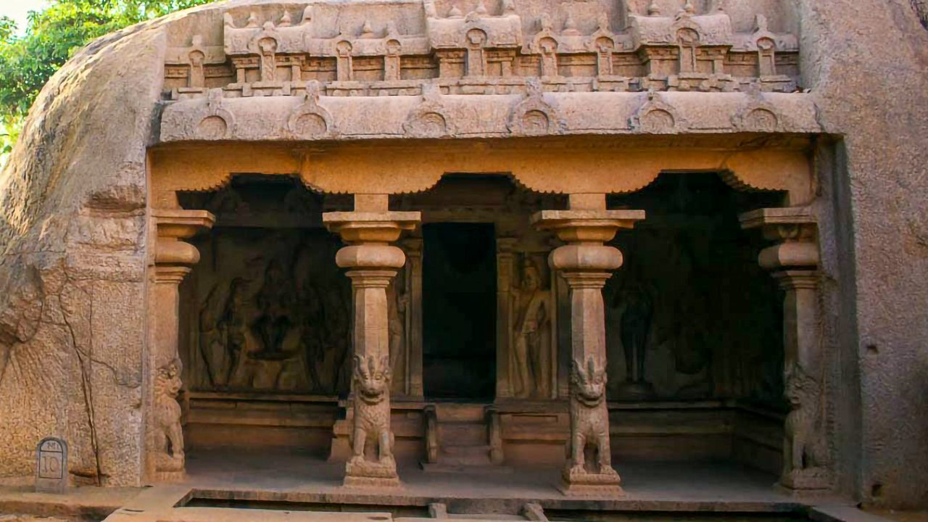

**Mahishasuramardini Cave**  
Durga, eight-armed and lion-mounted, charges the buffalo demon Mahisha. The composition is tensile and balanced: advancing diagonals countered by the demon’s mass, weapons radiating from the goddess’s core, soldiers and attendants amplifying momentum. It is a visual hymn to shakti—the feminine divine—triumphing over chaos. A companion panel often shows Vishnu reclining, framing the cave in a polarity of dynamic action and cosmic repose. 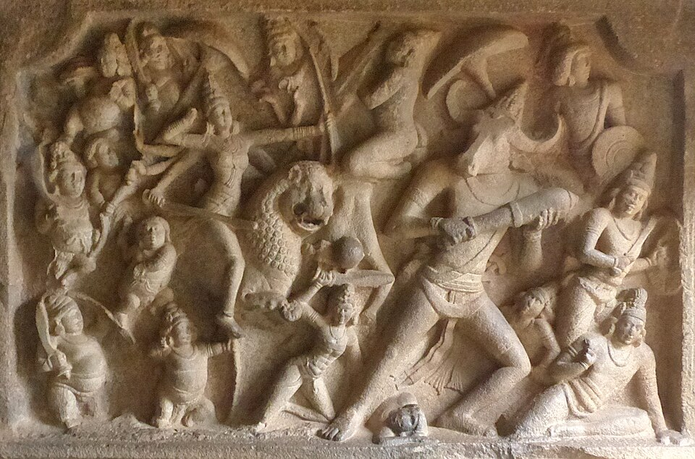

**Pancha Rathas**  
The five monoliths (attributed by later tradition to the Pandavas and Draupadi) each explore distinct formal solutions—plans, superstructure tiers, sculptural niches, animal balustrades—articulating a repertoire that later Dravidian temples refine in structural stone. While not consecrated shrines, they function as a didactic portfolio of temple typologies and a manifesto of Pallava architectural ambition.

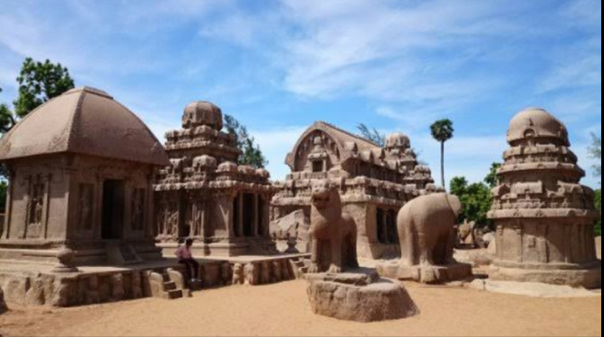

**Symbolism and Interpretation**

* Dharma, Bhakti, and Kingship: Ascetic devotion wins divine favor; rulers mirror cosmic order through righteous governance, temple patronage, and ritual sponsorship. Imagery binds personal piety with public kingship.
* Sacred Elements in Unity: Earth (Varaha and Bhu Devi), Water (Ganga’s descent, oceanside setting), and Divinity (Shiva-Vishnu-Durga triad) are composed into a single sacred ecology. The landscape itself—rock mass, sea breeze, monsoon wash—is absorbed into ritual meaning.
* Site as Sacred Geography: The coastline, granite outcrops, and natural clefts are not neutral backdrops; they are scripted as Vedic-puranic terrains where myth perpetually reenacts itself.

**Artistic and Cultural Significance**

**Artistic**  
Mahabalipuram provides the seedbed of South Indian temple form: tiered vimanas, porch-pillared mandapas, narrative relief cycles, guardian figures, and integrated iconographic programs. Its narrative sculpture achieves a rare synthesis—grand scale, clarity of storytelling, psychological immediacy, and compositional daring in unforgiving granite.

**Cultural**  
The ensemble proclaims Pallava power, piety, and cosmopolitanism. As a thriving port, Mahabalipuram radiated artistic influence across the Bay of Bengal, while absorbing and localizing broader Indic currents. The sculptural language—heroism, fertility, devotion—resonates with Tamil poetic and ethical ideals.

**Religious**  
For largely non-literate publics, these works operated as visual scripture. They gave tangible form to complex theology—avatars, shakti, linga worship—and framed devotion as both personal ascent (tapas) and communal welfare (rain, harvest, order).

**Global**  
Long before “land art,” Mahabalipuram fuses environment and art: the sea-salt air, granite outcrops, and monsoon-washed reliefs become co-authors of meaning. This site stands as an early and influential model of environmental integration in sacred art.

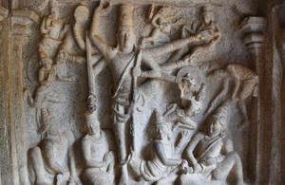

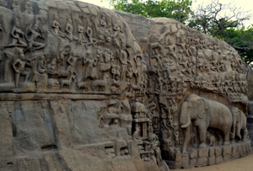

**Comparative Context**

* **Ajanta and Ellora**: Like Ajanta’s murals and Ellora’s rock-cut reliefs, Mahabalipuram uses narrative to teach and inspire. Unlike Ajanta’s painted interiors or Ellora’s deep excavations, Mahabalipuram dramatizes myth in open-air reliefs and monoliths, intensifying dialogue with landscape and light.
* **Influence on Chola and Pandya**: Later Cholas monumentalized the Pallava grammar—raising soaring vimanas (e.g., Thanjavur), elaborating Somaskanda programs, and enhancing bronze sculpture undergirded by Pallava narrative ethos. Pandya and later Vijayanagara traditions continued this iconographic and architectural lineage.
* **Continuity of Iconography**: The Varaha, Mahishasuramardini, Gajalakshmi, and Somaskanda schemes recur across South India, refined in scale, ornament, and ritual setting, yet retaining their Pallava-era clarity and moral resonance.

**Conclusion**Mahabalipuram’s rock-cut corpus marks the apex of Pallava creativity and the hinge between excavated sanctuaries and structural stone temples. Its integrated program—mythic narratives of salvation and justice, royal iconographies of legitimacy, and experimental temple prototypes—establishes the foundations of Dravidian temple architecture and South Indian sacred aesthetics. The site’s enduring power lies in its union of ascetic devotion, regal ambition, and environmental poetics: granite shaped into theology, coastline into cosmology, sculpture into living scripture. For art history, Mahabalipuram is not only a chapter of early medieval experimentation; it is the prologue to a millennium of South Indian temple art.

**Assignment 6:**

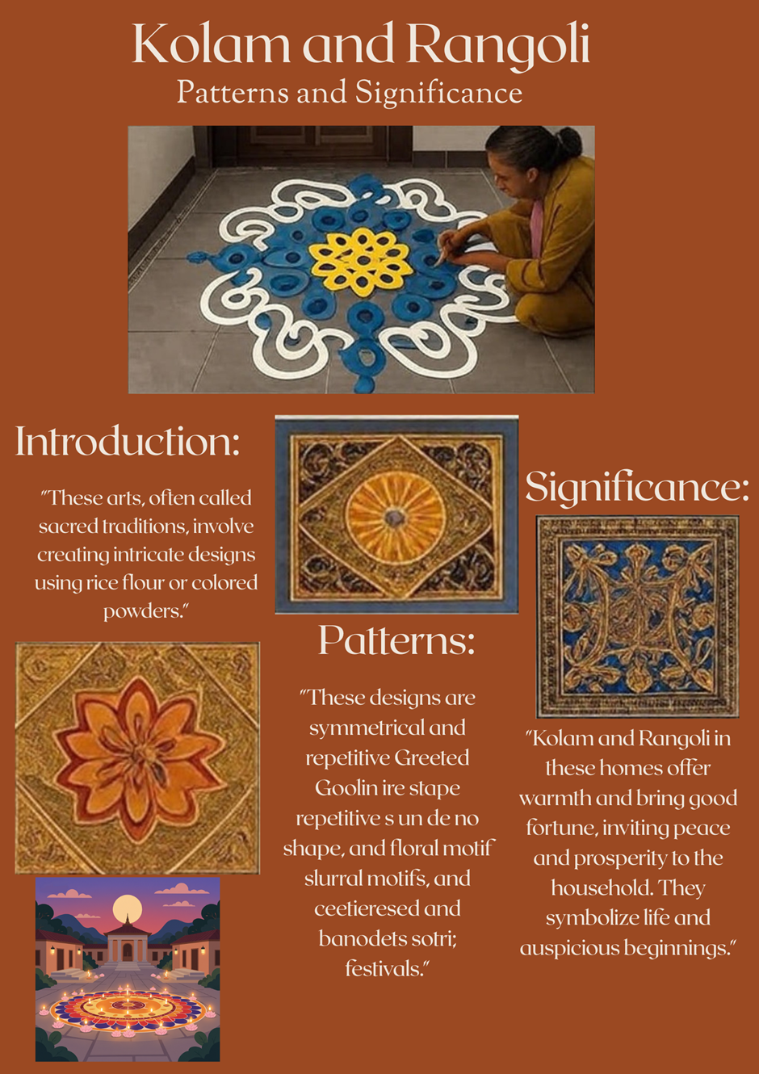

**Assignment 7:**Hayden Varughese Cheriyan – RA2311030010238  
Aryaman Chaudhary – RA2311030010222

**The Shore Temple – Main Highlight of Visit**

**Photo Captured**

* **Monument Name:** Shore Temple
* **Location:** Mahabalipuram, Tamil Nadu, India

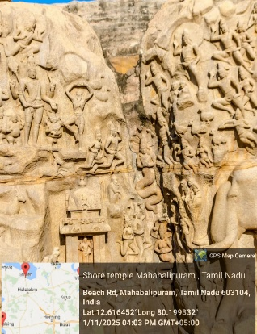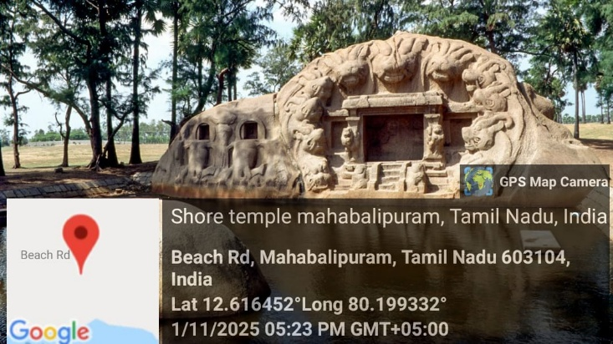

**Historical Background**

The **Shore Temple** is one of the oldest and most iconic structural stone temples in South India. Built during the reign of the **Pallava king Narasimhavarman II (Rajasimha)** in the early 8th century, the temple stands majestically on the Coromandel Coast overlooking the Bay of Bengal.

It was named the **Shore Temple** due to its proximity to the sea and served not just as a place of worship but also as a landmark for ancient maritime traders.

**Architectural Features**

* **Temple Type:** Structural (built using blocks of granite, unlike monolithic rock-cut shrines seen elsewhere in Mahabalipuram)
* **Architecture Style:** Dravidian
* **Layout:** Consists of three ornate sanctuaries — the two larger ones are dedicated to **Lord Shiva**, and the smaller one is dedicated to **Lord Vishnu**
* **Material Used:** Locally sourced granite
* **Highlights:**
  + Two-tiered pyramidal towers with intricate carvings
  + Bas-reliefs depicting mythological scenes
  + Nandi (bull) sculptures surrounding the temple courtyard
  + View of sunrise behind the temple gives it an ethereal backdrop

**Artistic and Cultural Significance**

* One of the few surviving temples built under the **Pallava dynasty**, who were pioneers in rock-cut architecture.
* Represents an important transition from **rock-cut** to **structural temple architecture** in India.
* Simultaneously exhibits religious symbolism and technical stone masonry excellence.
* Designated as a **UNESCO World Heritage Site** in 1984 due to its historical and artistic importance.

**Reflections from the Visit**

Standing in front of the Shore Temple was a deeply immersive experience. Its ancient carvings and ocean-backed scenery gave a glimpse into India’s rich cultural and spiritual heritage. The temple’s ability to withstand centuries of weathering from salty sea air is a testament to the mastery of Pallava architects.

From this visit, I learned about:

* The evolution of temple architecture in India
* How mythology, history, and art are beautifully intertwined
* The importance of preserving such historic monuments

**Assignment 8:**

**Introduction:**

Festivals in India hold deep cultural and spiritual significance, and art has always been an essential part of celebration. Community-based festival art projects, such as Rangoli and floor paintings, promote unity, creativity, and shared identity. For this project, I collaborated with local community members to create a vibrant Rangoli installation for a regional festival.

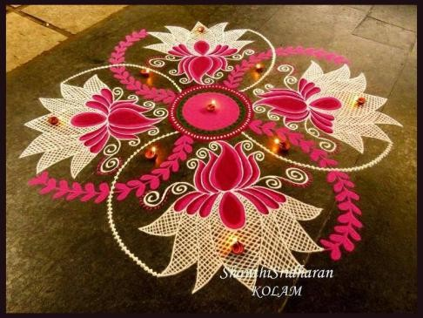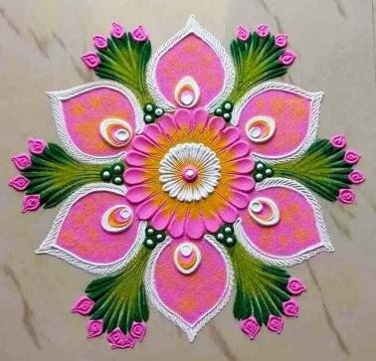

**Project Process:**

1. Planning: The team decided on a floral geometric design representing harmony and prosperity.
2. Collaboration: Each member contributed ideas, colour combinations, and designs inspired by traditional patterns.
3. Execution: Using coloured powders and natural dyes, we created a 10-foot floor Rangoli in the center of the community space.
4. Documentation: The process was recorded using photographs and short video clips to capture teamwork and artistic flow.

# Community Involvement:

The participation of elders and children brought emotional warmth to the project. Elders guided us with traditional techniques, while children added enthusiasm and creativity. This intergenerational exchange made the artwork more meaningful and inclusive.

# Final Artwork Description:

The final Rangoli displayed a blend of modern symmetry and traditional motifs using vibrant hues of red, yellow, blue, and green. At the center was a lotus symbolizing purity and growth. The artwork became a focal point of the festival, admired by many visitors.

# Conclusion:

The Community Festival Art Project not only enhanced artistic understanding but also strengthened social bonds. Through this collaboration, I realized how collective creativity can transform simple art into a shared celebration of culture and emotion.

# References:

* Wikipedia: Rangoli Art of India
* Cultural India: Festival Art and Community Traditions
* India Today: The Revival of Community Arts During Festivals

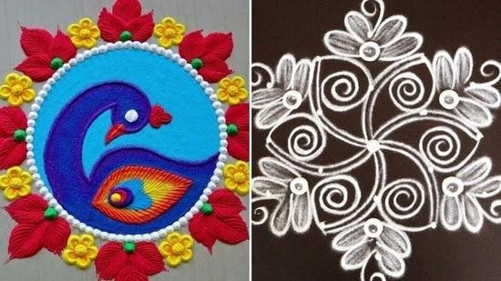

**Assignment 9:**

**Introduction**

The Progressive Artists’ Group (PAG) was formed in 1947 in Bombay (now Mumbai) by artists who sought to break free of colonial‑academic styles and express modern India through bold new visual languages. Key founding members include F. N. Souza,

M. F. Husain, S. H. Raza, K. H. Ara, H. A. Gade and S. K. Bakre. Their works mix Indian themes and motifs with influence from European modernism (cubism, expressionism, etc.).

**Selected Original Artwork**

I have chosen the artwork ‘Bindu’ by S. H. Raza as my inspiration.

Why this piece:

* + It represents PAG’s fusion of Indian spirituality with modernist abstraction.
  + The geometric composition and vibrant palette appealed to me.
  + The spiritual symbolism of the ‘Bindu’ aligns with my interest in calmness and

focus.

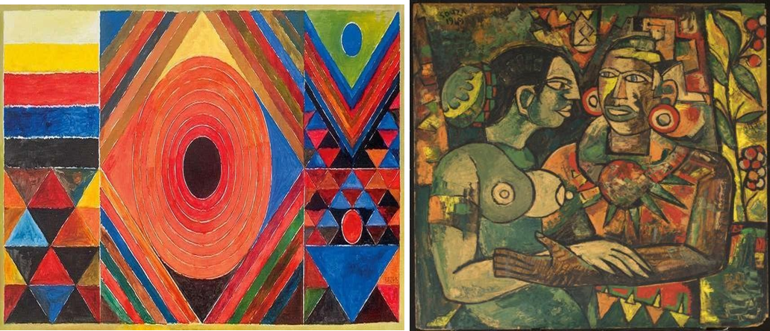

**My Recreation – Medium & Process**

Medium used: Digital Art Process summary:

* + Studied the symmetry and balance of Raza’s original composition.
  + Recreated geometric forms digitally, experimenting with gradients and textures.
  + Modified the palette to cooler tones to reflect my personal interpretation of peace.
  + Final touches focused on subtle glow effects to enhance meditative depth.

**Comparison Essay**

Technique & Style:

Raza’s ‘Bindu’ emphasizes geometric abstraction and strong colour symbolism. My

recreation retains the circular motif but simplifies linework for minimalism.

Emotional & Conceptual Aspects:

Raza’s original expresses spiritual energy; mine channels a calmer, digital-era tranquility. Both explore focus and inner balance.

Reflections & Learning:

* Gained insight into symbolic abstraction.
* Learned how small shifts in hue affect emotional tone.
* Appreciated PAG’s ability to merge modern forms with Indian philosophy.

**Conclusion**

Recreating Raza’s ‘Bindu’ deepened my understanding of abstraction and emotional minimalism. It showed how art can blend modern technique with deep philosophical meaning, and how reinterpretation can reflect personal identity while respecting legacy.

**References**

* + Wikipedia: Progressive Artists’ Group (PAG)
  + Artisera Blog: The Progressive Artists’ Group and Its Impact on Indian Modern Art
  + Asia Society: The Progressive Revolution – Modern Art for a New India